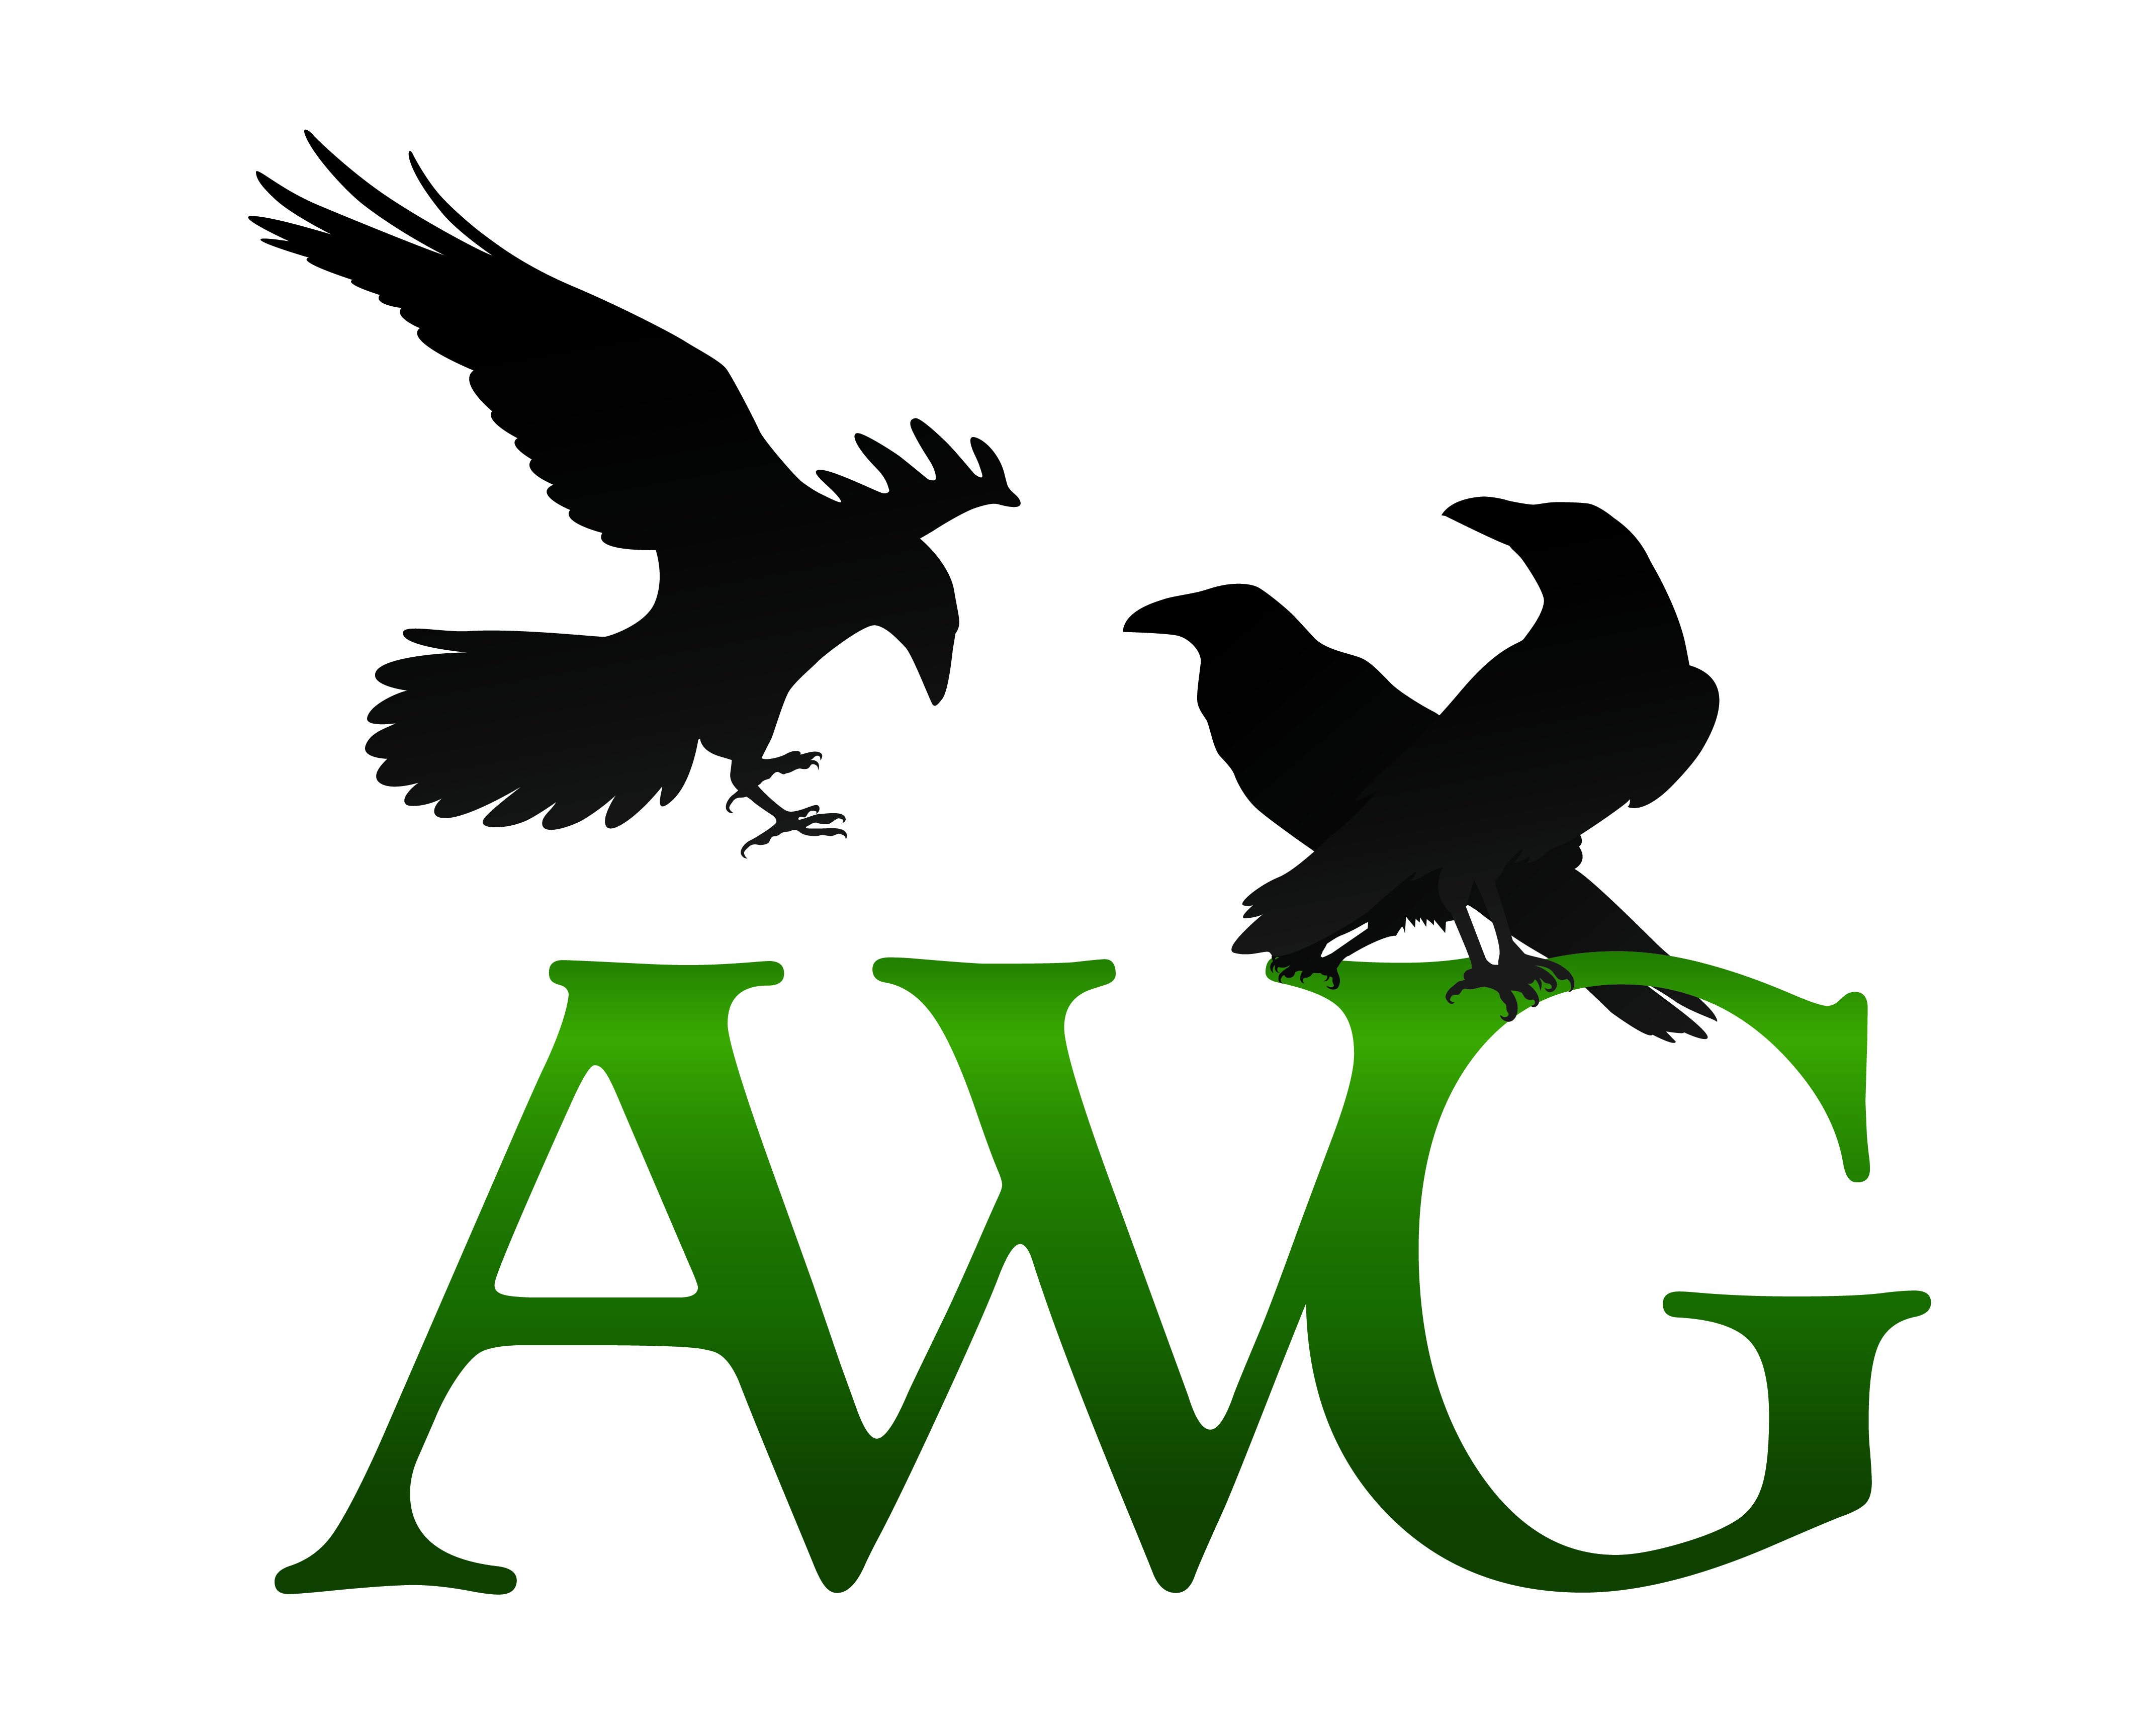
The Lin Halterman Memorial Grant is awarded in memory of Linda L. Halterman, a charter member and the second secretary of the Alaska Writers Guild. An indefatigable worker, she plowed into projects with a focus that was never diverted. Her work continued until one summer day in 2009, when she was diagnosed with cancer and given six months to live. She finished her family legacy, “Journey of a Lifetime,” and fought the issue of cancer with as much determination as she mustered in her other pursuits. Her husband, John, and her family approved the Lin Halterman Memorial Grant Fund, awarded every year to current members of the Alaska Writers Guild to aide them in pursuing their writing goals.

This year, one $500 grant will be awarded. All applicants must be current members of the Alaska Writers Guild in paid status at the time of their application. Please complete the following and return no later than Tuesday, October 31, 2023 by email to: grants@alaskawritersguild.com

- Your Contact Information:

Name
Address City / State / Zip
Phone Email

- Writer Bio: Please include your writer biography, including any published works, awards, or writing related education (no more than 500 words):

- Service to other writers: Please describe any volunteer work to assist in the advancement of other writers. Examples include volunteering for writers conferences, assisting with youth writing education, being an active member of a critique group, or donations of time, services, or goods for writer-related fundraising events (no more than 500 words):

- Use of grant funds: Please describe what you would use your grant award funds toward. Examples include hiring an editor, enrolling in writing courses, attending a conference, or travel for research. Please be as specific as possible (no more than 500 words):

- Writing sample: Please provide a sample of your writing. This can be in any genre, and can be either a complete story or an excerpt from a larger body of work (no more than 500 words):

